(29.8.2026)
MYSQL PROJECT- HARSHINI PRASANNA
Employee Details Management System
1. CREATE DATABASE

CREATE DATABASE EmployeeDetails;

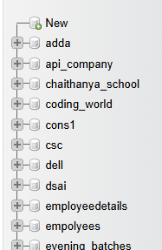

2. Create Employee Table

CREATE TABLE Employee EmployeeID INT PRIMARY KEY, FirstName VARCHAR(50), LastName VARCHAR(50), Gender VARCHAR(10),DateOfBirth DATE, Department VARCHAR(50), JobTitle VARCHAR(50), Salary DECIMAL(10,2), Email VARCHAR(100),Phone VARCHAR(15), City VARCHAR(50)

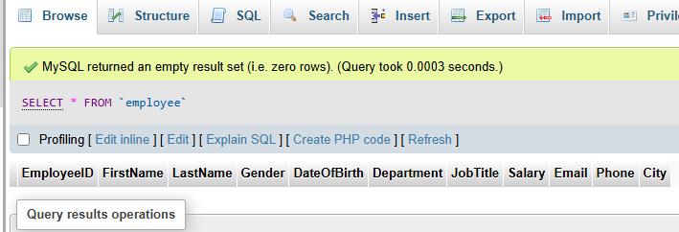

3.Insert Employee Details

INSERT INTO employee(EmployeeID, Firstname, LastName ,Gender, DateOfBirth, Department,
JobTitle, Salary, Email, Phone, City)VALUES
(1, 'Aarav', 'Singh', 'M', '1994-03-23', 'IT', 'Team Lead', 90000.00, 'aarav.singh@gmail.com', '9876543210', 'Punjab'),
(2, 'Priya', 'Sharma', 'F', '1996-07-15', 'HR', 'HR Manager', 78000.00, 'priya.sharma@gmail.com', '9876543211', 'Delhi'),
(3, 'Rohan', 'Vishwanath', 'M', '1993-11-08', 'Finance', 'Financial Analyst', 72000.00, 'rohan.vish@gmail.com', '9876543212', 'Madurai'),
(4, 'Ananya', 'Patil', 'F', '1998-02-19', 'Marketing', 'Marketing Executive', 35000.00, 'ananya.pil@gmail.com', '9876543213', 'Ahmedabad'),
(5, 'Vikram', 'Reddy', 'M', '1991-09-27', 'IT', 'Software Engineer', 35000.00, 'vikram.reddy@gmail.com', '9876543214', 'Hyderabad'),
(6, 'Sneha', 'Nair', 'F', '1997-05-12', 'Sales', 'Sales Executive', 42000.00, 'sneha.nair@gmail.com', '9876543215', 'Kochi'),
(7, 'Karan', 'Mahendrean', 'M', '1995-12-03', 'Operations', 'Operations Manager', 81000.00, 'karan.mahi@gmail.com', '9876543216', 'Pune'),
(8, 'Meera', 'Ramakrishnan', 'F', '1999-04-25', 'IT', 'Web Developer', 68000.00, 'meera.rk@gmail.com', '9876543217', 'Chennai'),
(9, 'Arjun', 'Krishna', 'M', '1992-06-17', 'Finance', 'Accountant', 40000.00, 'arjun.krish@gmail.com', '9876543218', 'Hyderabad'),
(10, 'Neha', 'Gunadharan', 'F', '1996-10-30', 'HR', 'Recruiter', 58000.00, 'neha.guna@gmail.com', '9876543219', 'combiatore'),
(11, 'Rahul', 'Joshi', 'M', '1990-01-14', 'IT', 'Project Manager', 55000.00, 'rahul.joshi@gmail.com', '9876543220', 'Bengaluru'),
(12, 'Kavya', 'Menon', 'F', '1998-08-21', 'Marketing', 'Content Manager', 67000.00, 'kavya.menon@gmail.com', '9876543221', 'Kolkata'),
(13, 'Aditya', 'Chopra', 'M', '1994-09-05', 'Sales', 'Sales Manager', 53000.00, 'aditya.chopra@gmail.com', '9876543222', 'Chandigarh'),
(14, 'Ishita', 'Bose', 'F', '1997-03-11', 'Operations', 'Operations Executive', 61000.00, 'ishita.bose@gmail.com', '9876543223', 'Bhubaneswar'),
(15, 'Manish', 'Malhotra', 'M', '1989-07-29', 'Finance', 'Finance Manager', 92000.00, 'manish.malhotra@gmail.com', '9876543224', 'Surat'),
(16, 'Pooja', 'Dhamodharan', 'F', '1995-11-16', 'IT', 'Database Administrator', 36000.00, 'pooja.dhamo@gmail.com', '9876543225', 'chennai'),
(17, 'Siddharth', 'Rajini', 'M', '1993-04-07', 'HR', 'HR Executive', 39000.00, 'siddharth.raj@gmail.com', '9876543226', 'Mysore'),
(18, 'Riya', 'Agarwal', 'F', '2000-01-22', 'Marketing', 'Digital Marketing Executive', 33000.00, 'riya.agarwal@gmail.com', '9876543227', 'Noida'),
(19, 'Dev', 'Khanna', 'M', '1996-06-09', 'IT', 'System Administrator', 36000.00, 'dev.khanna@gmail.com', '9876543228', 'Gurugram'),
(20, 'Simran', 'kashish', 'F', '1999-12-18', 'Sales', 'Business Development Executive', 63000.00, 'simran.ksh@gmail.com', '9876543229', 'Kochi');

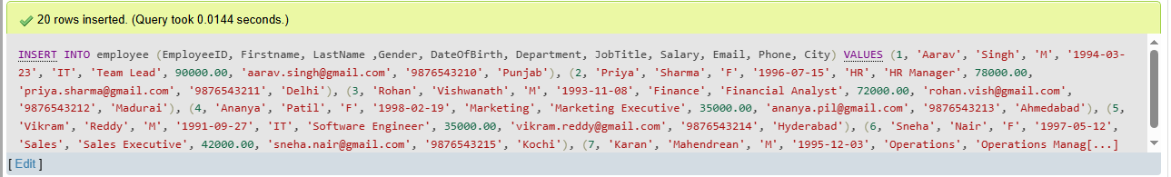

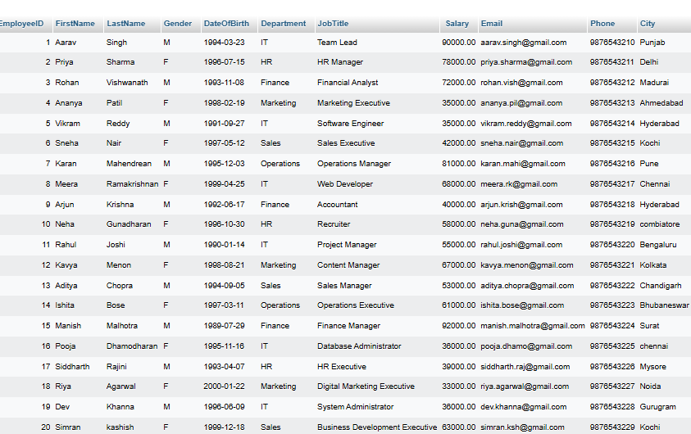

4.Display All Employees

SELECT FirstName , LastName FROM `employee`;

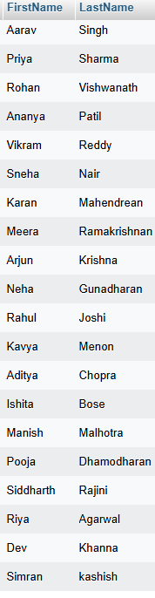

5.Find Employees in IT Department

SELECT * FROM `employee` WHERE Department='IT';

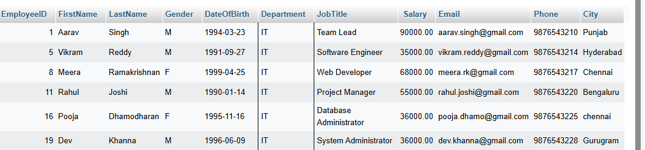

6.Find Employees With Salary Greater Than ₹40,000

SELECT * FROM `employee` WHERE Salary>40000;

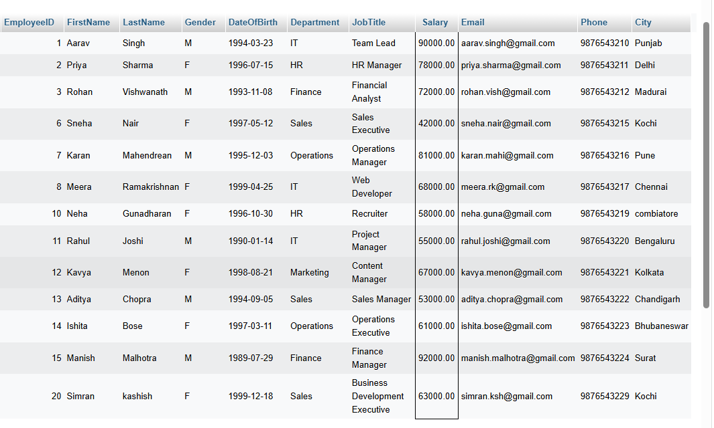

7.Sort Employees by Salary

SELECT * FROM `employee` ORDER BY Salary ASC

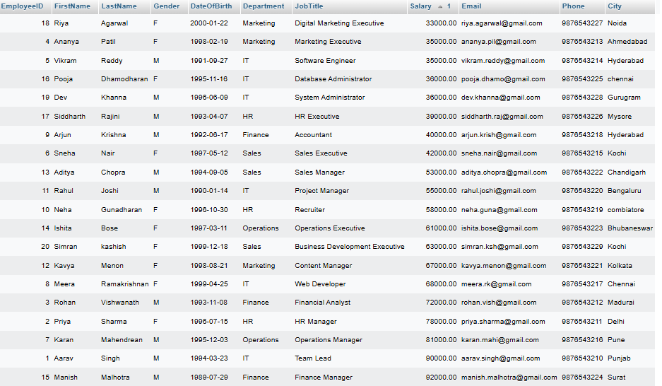

8.Find Highest Salary

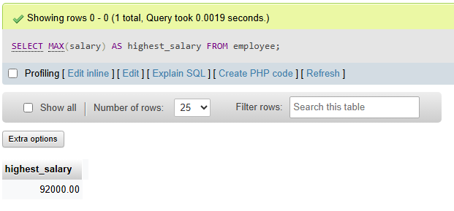

9.Count Employees in Each Department

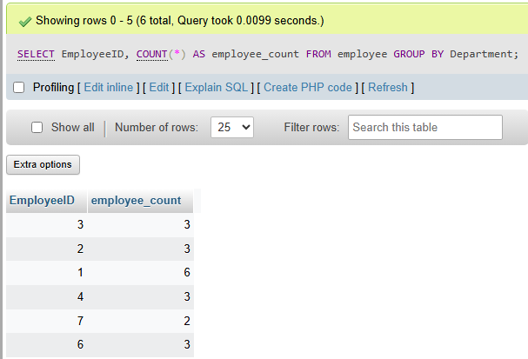

10.Find the Highest-Paid Employee

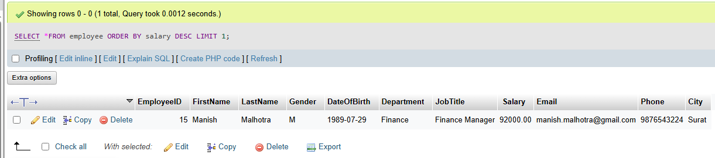

11.Find Employees From Chennai

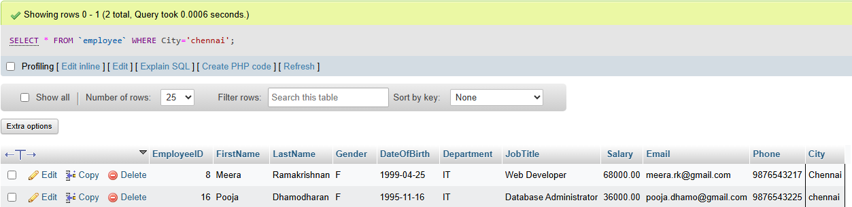

12.Display employee names and salaries.

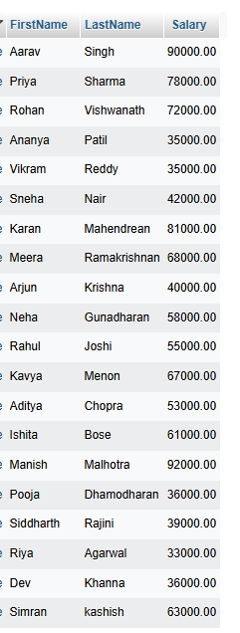

13.Find an employee using Employee ID.

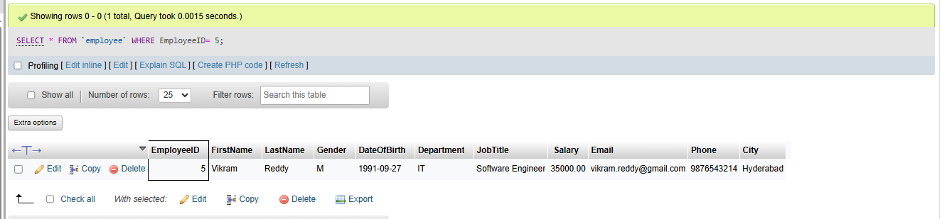

14.Display employees in descending order of salary

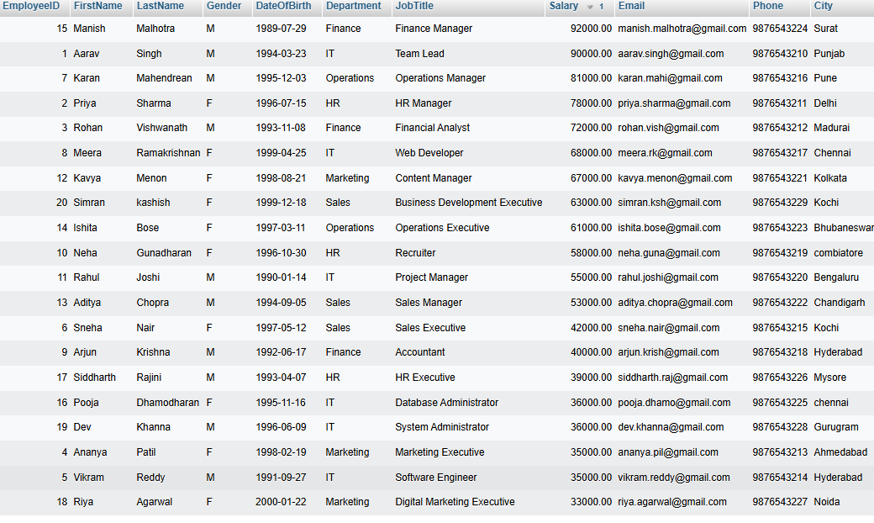

15.Count employees in each department.

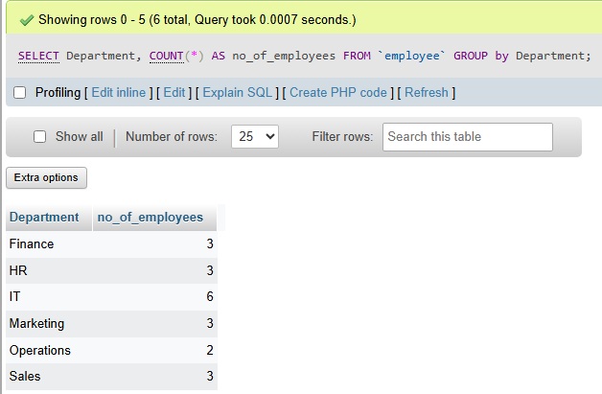
16.Display departments having more than 5 employees.

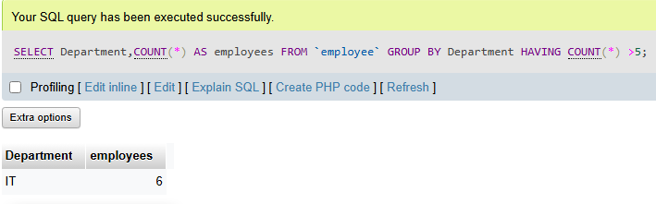

17.Find duplicate email addresses.

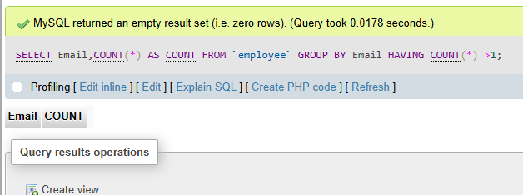

18.Find the department with the highest average salary.

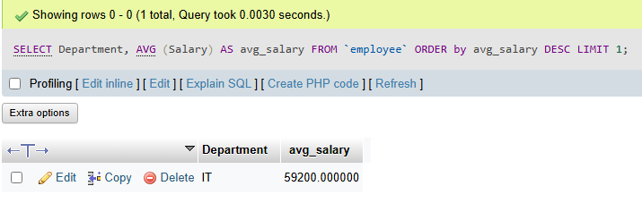

19.Find the number of male and female employees.

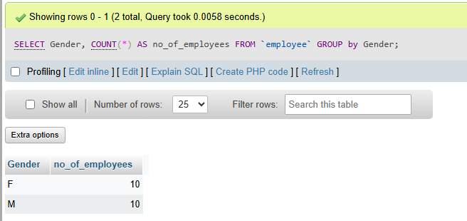

20.Display the top 5 highest-paid employees.

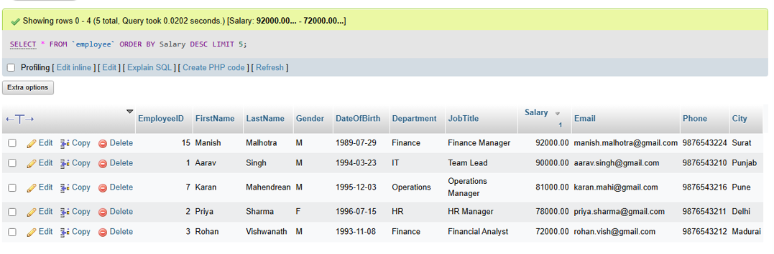
21.Display employees whose name starts with the letter 'A'.
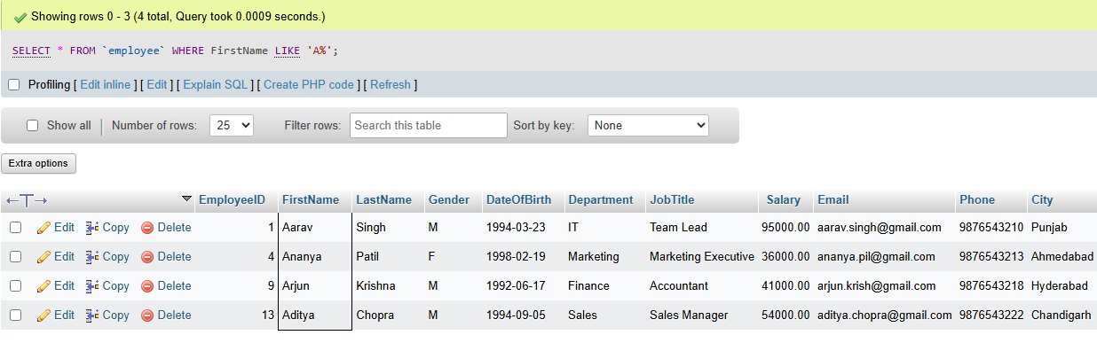

22.Display employees whose salary is between ₹30,000 and ₹60,000.

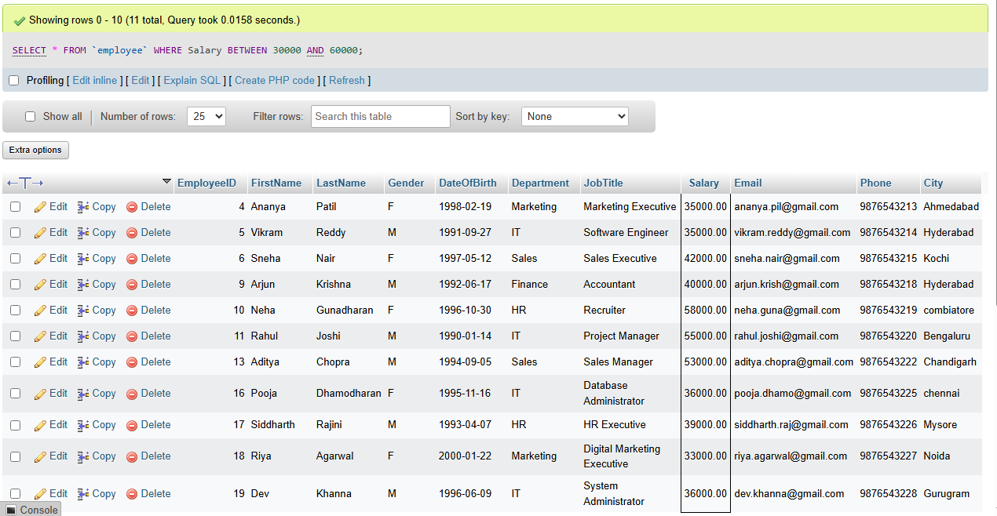

23Find the average salary.

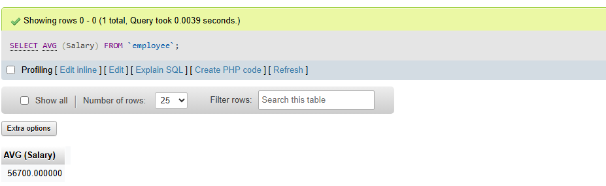

24. Find the average salary of each department
